
GPS^{education}
Green & Pink for Sustainable Education

II SLOT OF SEMINARS UNISANNIO

introduction to artificial intelligence and technological sustainability
The seminar focuses on the disruptive role of artificial intelligence and the new profiles of sustainable technology

WHEN
On Wednesday 28 of January 2026 from 14:00 PM to 16.00 PM (Central European Time - Rome)
VENUE
Meeting room
Green & Pink for Sustainable Education | Partecipazione alla riunione https://meet.google.com/ezz-mvsg-wyy
University of Sannio

For students who follow the lessons in-person the rooms is:
Room 29P - via Delle Puglie, first floor

machine hermeneutics and ethics
The seminar analyses the notion of hermeneutical activity performed by machines. Machines are now capable of making the very interpretive tasks, using artificial intelligence algorithms based on the technology of machine learning that used to be the exclusive domain of human beings and its relation to the ethic.

WHEN
On Tusday 3 of February 2026 from 14:00 PM to 16.00 PM (Central European Time - Rome)
VENUE
Meeting room
Green & Pink for Sustainable Education | Partecipazione alla riunione https://meet.google.com/ezz-mvsg-wyy
University of Sannio

For students who follow the lessons in-person the rooms is:
Room 29P - via Delle Puglie, first floor

__________________________________
TRAINING SUPERVISOR AND LECTURER: Prof.ssa Mariah Brochado
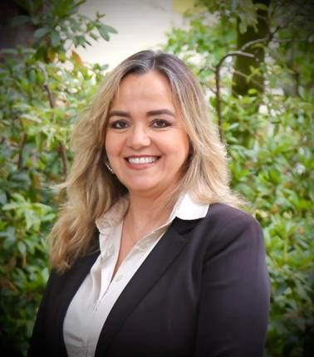 | SHORT BIO  Full Professor of Philosophy of Technology at the Federal University of Minas Gerais.  Coordinator of the PHILOTECH: Philosophy of Technology Applied to Digital Law/Jean Monnet Center of Excellence (European Union/UFMG).  Director of Human Rights at the Institute of Law and Artificial Intelligence (IDEIA) of Minas Gerais.  Former Deputy Secretary of State for Civil Affairs and Institutional and International Relations of Minas Gerais  She conducts research in the areas of AI and ethics.

