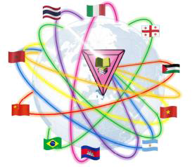
GPS^{education}
Green & Pink for Sustainable Education

II SLOT OF SEMINARS UNISANNIO

Revolution 4.0 and Gender relations in times of crisis: the brutalization of the commodity-producing patriarchy
The seminar is devoted to the analysis of the impact of the Fourth Industrial Revolution (Industry 4.0) on the patriarchal systems during global crises, revealing intensified exploitation where technological shifts and capitalist demands exacerbate gender inequality, often by devaluing women's reproductive labor.

WHEN
On Tusday 27 of January 2026 from 14:00 PM to 16.00 PM (Central European Time - Rome)
VENUE
Meeting room
Green & Pink for Sustainable Education | Partecipazione alla riunione https://meet.google.com/ezz-mvsg-wyy
University of Sannio

For students who follow the lessons in-person the rooms is:
Room 29P - via Delle Puglie, first floor

Crisis Management or Just War?: Environmental (Un)sustainability and Attempts for Possible Futures
The seminar analyses the impact of non-sustainability on the environment and the possible negative effects that result from it.

WHEN
On Monday 2 of February 2026 from 14:00 PM to 16.00 PM (Central European Time - Rome)
VENUE
Meeting room
Green & Pink for Sustainable Education | Partecipazione alla riunione https://meet.google.com/ezz-mvsg-wyy
University of Sannio

For students who follow the lessons in-person the rooms is:
Room 29P - via Delle Puglie, first floor

__________________________________
TRAINING SUPERVISOR AND LECTURER: Prof.ssa Ana Elisa Correa
 | SHORT BIO  Professor of Sociology at the Social Sciences Sector of the Colégio Técnico of the Federal University of Minas Gerais (COLTEC/UFMG-MG).  She conducts research in the areas of Sociology, Political Science, Education, and Geography, with particular attention to the following thematic areas: the crisis of capital, the crisis of labor, and capitalism 4.0; the critique of value-dissociation; urban and rural social movements; feminism and gender relations; and the environmental crisis.

